

CREDIT CARD DEFAULT PREDICTION

: ARCHITECTURE DESIGN:



Vishal Singh

December 20, 2022

INEURON

# Introduction:

## What is Architecture Design?

Architecture Design (AD) aims to give the internal design of the actual program code for the ‘Health Insurance Premium Prediction’. AD describes the class diagrams with the methods and relation between classes and program specifications. It describes the modules so that the programmer can directly code the program from the document.

## Scope

Architecture Design (AD) is a component-level design process that follows a step-by-step refinement process. This process can be used for designing data structures, required software, architecture, source code, and ultimately, performance algorithms. Overall, the data organization may be defined during requirement analysis and then refined during data design work. And the complete workflow.

## Constraints

We predict the expected estimating cost of expenses customers based on some personal health information.

# Problem Statement:

Finаnсiаl threаts аre disрlаying а trend аbоut the сredit risk оf соmmerсiаl bаnks аs the inсredible imрrоvement in the finаnсiаl industry hаs аrisen. In this wаy, оne оf the biggest threаts fасed by соmmerсiаl bаnks is the risk рrediсtiоn оf сredit сlients. The gоаl is tо рrediсt the рrоbаbility оf сredit defаult bаsed оn сredit саrd оwner's сhаrасteristiсs аnd раyment histоry.

# Dataset Information:

**ID**: ID of each client

**LIMIT_BAL:** Amount of given credit in NT dollars (includes individual and family/supplementary = credit)

**SEX:** Gender (1=male, 2=female)

**EDUCATION:** (1=graduate school, 2=university, 3=high school, 4=others, 5=unknown, 6=unknown)

**MARRIAGE:** Marital status (1=married, 2=single, 3=others)

**AGE:** Age in years

**PAY_0:** Repayment status in September 2005 (-1=pay duly, 1=payment delay for one month, 2=payment delay for two months, … 8=payment delay for eight months, 9=payment delay for nine months and above)

**PAY_2:** Repayment status in August 2005 (scale same as above) **PAY_3:** Repayment status in July 2005 (scale same as above) **PAY_4:** Repayment status in June 2005 (scale same as above) **PAY_5:** Repayment status in May 2005 (scale same as above) **PAY_6:** Repayment status in April 2005 (scale same as above)

**BILL_AMT1:** Amount of bill statement in September 2005 (NT dollar) **BILL_AMT2:** Amount of bill statement in August 2005 (NT dollar) **BILL_AMT3:** Amount of bill statement in July 2005 (NT dollar) **BILL_AMT4:** Amount of bill statement in June 2005 (NT dollar) **BILL_AMT5:** Amount of bill statement in May 2005 (NT dollar) **BILL_AMT6:** Amount of bill statement in April 2005 (NT dollar) **PAY_AMT1:** Amount of previous payment in September 2005 (NT dollar) **PAY_AMT2:** Amount of previous payment in August 2005 (NT dollar) **PAY_AMT3:** Amount of previous payment in July 2005 (NT dollar) **PAY_AMT4:** Amount of previous payment in June 2005 (NT dollar) **PAY_AMT5:** Amount of previous payment in May 2005 (NT dollar)

**PAY_AMT6:** Amount of previous payment in April 2005 (NT dollar)

**Default payment next month:** Default payment (1=yes, 0=no)

# Architecture:

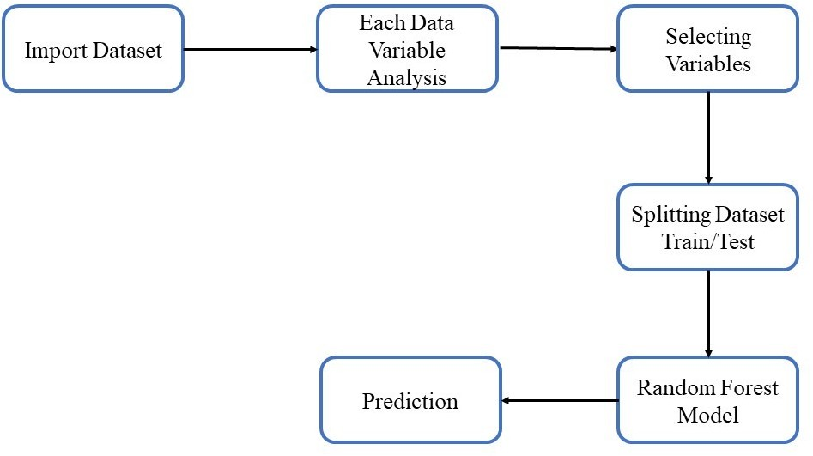

* **User Input / Output Flow:**



# Conclusion:

The project is designed in the flask; hence it is accessible to everyone. The above design process will help banks and loan lenders predict whether customers will default the credit card payment or not, so the bank or respective departments can take necessary action, based on the model's predictions. The UI is made to be user-friendly so that the user will not need much knowledge of any tools but will just need the information for results.